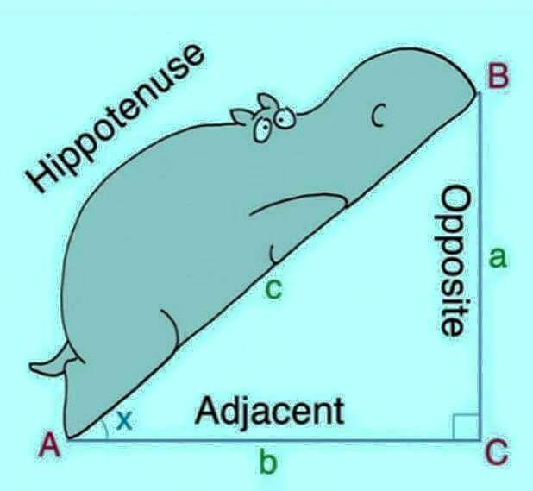

The presented picture illustrates a right angle triangle. The base is named as the adjacent represented as small case b, the elevation has been names small case a and the hypotenuse has been names as small case c. There is also a picture of a 'funny' looking hippopotamus leaning on the hypotenuse probably for the purpose of memorizing the position of hypotenuse.

This picture demonstrates the ABC right angle triangle, in which a represents opposite side  and b represents adjacent side of angle  X angle. And C denotes hippotenuse or hypotenuse.  The picture of hippopotamus placed on the hypotenuse to remember the hypotenuse.

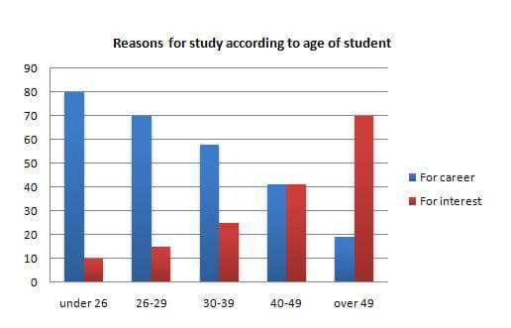

This bar chart illustrates the comparison between the students age and the reason for the studies, It is clearly seen that 80% of the students who are under 26 studies due to their career, and it started decreasing and reached less than 20% with age over 49.

As of for Interest it is seen that under 26 had started with 10% and ended with 70% with over 49, Overall it’s clear that when the students grow on age, the reason is changing from Career to Interest....

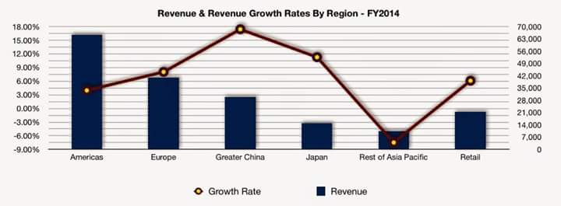

The given bar illustration depicts the revenue and line shows revenue growth rate in particular 6 countries in 2014.It is crystal clear that Greater degree of revenue comes from America, accounted for 16%, following by Europe with almost half of America's revenue. Moreover other remaining countries revenue  was below 3%.

As for as revenue growth rate is consirned Greater china had highest growth rate  with 18% and Rest of Asia Pacific was reckoned with lowest revenue and revenue growth rate in financial year.

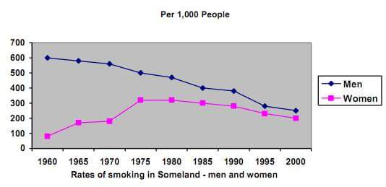

The line graph highlights the rate of smoking in Someland by both men and women over 40 years from 1960 to 2000. Male smokers were the highest in 1960 at 600 thousand and it gradually decline to a low of 300 thousand in 2000. On the other hand, the number of women smokers was the lowest in 1960 at 100 thousand and it gradually increase, peaking at 300 thousand in 1975 and eventually decreased to 200 thousand in 2000. Overall, although men were traditionally heavier smokers than women in 1960, both are smoking at almost the same rate at 250 to 300 thousand in 2000

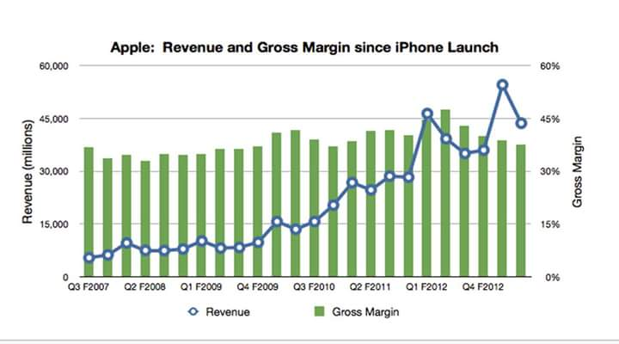

The statistical data depicts information regarding revenue gross margin from 2007 to 2012.As we can determine sales sky rocketed in 2012 up to 70,000 and in same year we can find significant decline. However, in 2007 sales hardly touched 5000.Despite with lots of ups and downs sales  had fluctuated between  2008 to 2011.In conclusion; IPhone have had turbulent sales for 4 years.

The graph shows the revenue and gross margin of apple since the launch of iphone over FY2007 to FY2012. We can see that there has been a steady rise from Q3FY2007 to Q1FY2012 when it reaches 45 Bn in revenue. After that , the revenue fluctuates for subsequent two quarters and in Q4FY2012 it again reaches the same revenue 45Bn. The gross margin was consistent in the range of 32% to 46% throughout the period.

This graph depicts Revenus & Gross Margin since Apple IPhone launch, Revenue went up unsteadly over the period of Q32007 to Q42012,In Q12012 it reached to level of 45 million revenue compare from 2008 to  20010, After that revenue flctuate for subsequent two quaters and in Q42012 it grew up & reached to the highest peak of 55 mill Despite of all up & downs in revenue gross margin consistenly in range from 30 % to 40 %through out the period.

This bar graph shows the revenue and gross margin since apple iphone launch from the year 2007 till 2012. In year 2007 q3 revenue gross margin was at 15,000 whereas it steadly increased in the year 2012q1 upto 45% as gross margin and it reached upto 55% in 2012 q4.

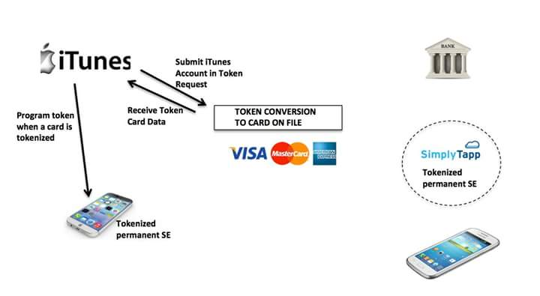

This diagram shows the process of token conversion to card file by using itunes application in iphone. Firstly submit itunes account in Token request then you will receive a card token after that itunes will program token when a card is tokenized finally tokenised SE will be recieved by itune in iphone.

This worklow expalin processing of token using iphone, first you have to submit token request using iTunes Account on receiving confirmation from your bank accout , progam will active token on you smart phone permanently

The images describes the processing of token via apple phone, first you have to submit account token  request , the request will connects to your concerned bank in last you will receive the confirmation on your same phone. Smart phone are going to have knock on effects on banks.

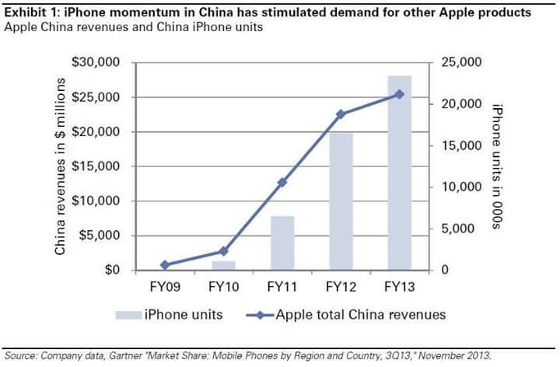

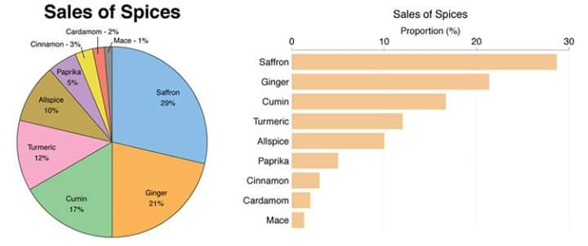This image elucidates the information about stimulated demand for other apple products due to iphone momentum in china. The bar graph nd line graph depicts the iphone units and apple total china revenues. The Maximum units sold were in FY 2013 starting from app 0 units from FY2009. The revenue also increased rapidly from FY2009 to 2013 from $0m to $25m.

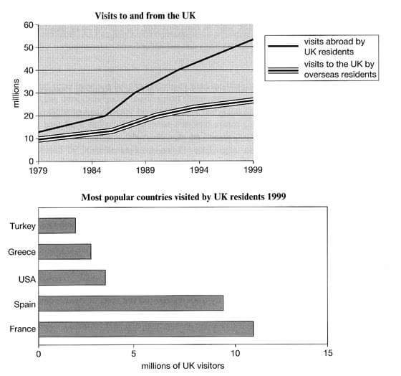The given pie chart and vertical bar graph exhibit the sales of spices in percentage. It is clearly evident that sale of saffron is 29% and closely followed by ginger 21%. Furthermore, third place retain by cumin with 17%. In addition, the bottom three places occupied by cinnamon, cardamom and mace with 3%,2%and 1% respectively . In recapitulate, we can say that saffron holds the top position among all spices in terms of sale of spices.

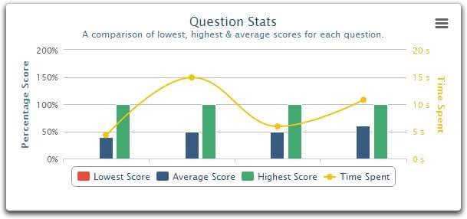The line graph elucidates the number of visitors come in England and English people travelled other countries. It is clearly seen that English people travel more than overseas resident. In 1979 more than 10 million English people travelled abroad and swelled significantly year by year and ended up more than 50 millions in 1999. On the other side, overseas people started with 10 million and increased gradually and reached to 28 millions in 1999. Moving on, vertical bar graphs depicts the favorite countries visited by English people.  It is clearly observed that first place France more than 10 millions travelled and than Spain and least travel countries  were Turkey and Greece less than 5 millions. Therefore, we can say that France is the favorite  country for UK residents  among other countries.

The graph depicts the comparison of lowest, highest and average scores for each questions and its relevant time spent of them. It is quite apparent that there was no lowest score recorded for any question and all the average score for each question has same taken the same amount of time, i.e., around 5 sec , however for highest score the time spent on each question is not more than 10 sec.............Akeel please suggest.

the picute shows the question statistics which is basically a comparison of lowest, highest nd average scores for each question. We can see that on in order to score average the amount of time spent is 5s or 50%.. and for highest score the amount of time spent is 10s or 100%.. it shows that if someone wants highest score, they must give time and read the question properly

This graph precisely shows that, for first average question takes minimum time around 5 seconds, however, these trends changed from other questions to the average scored questions. Besides, the highest score questions are spent maximum time was 7 Sec and it varies from one to another. In and all, noticeably, shows the lowest scores not spent any time.

This graph shows the comparison of time spend for lowest,average and highest score for 4 different questions. It can be clearly seen that, none of the students scored lowest score for any of the questions and the second question is the most time consuming question among all questions. However, question no 1 and no 3 were not took more than 6 seconds to complete where as highest score students took around 8 seconds to complete question 1. Average score students consumed around 10 secs to complete question 4. In conclusion, it cabe said that question 2 and question 4 are much harder than other two questions.

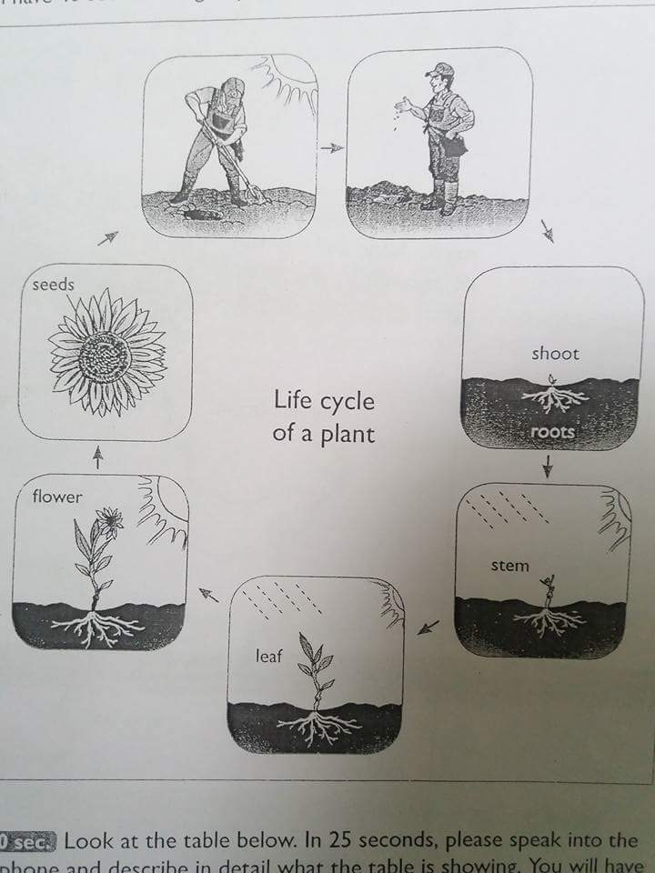The image describes about the "Life cycle of plant”. It consists of 6 seven steps. The beginning started by human plantation seed on earth, following into shoot-steam-leaf and in last as flower and cycle continues with seeds again.

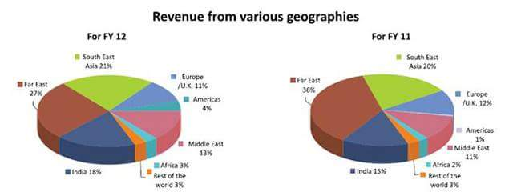

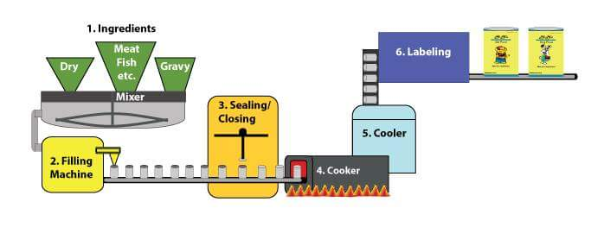The diagram compares the Revenues of two financial years from various geographies.The top contributor is Far East in both FY11 and FY12 with slight decrease in FY12 from 36% to 27%. South East and India stood at 2nd and 3rd positions respectively in both the years with former increasing from 20% to 21% and latter from 15% to 18%. Africa stood as one of the least contributors in both the years

This diagram illustrates the process of ready to eat food preparation.It is immediately apprent that, there are 6 steps.Intially raw materials get mixed and then pass to the filling machine following with sealing of lid.Once sealed these can go to cooker for cooking that makes it edible.Finally after cooling and lebeling, cans are ready to dispatch.

PTE Academic Describe Image Tips

**#1. Be familiar with types of image**

There is a few kind of images that may appear for this section, so you need to get yourself familiar with it hence you will not go panic even if you encounter one. Imagine going for the same movie again and again, boring huh? ok, that's not what I mean. What I mean is learning to expect the type of movies you are going to watch, so it would be worthwhile for your money and, of course, your precious time.   
  
During the test, do not be surprised if you encounter a picture, line graph, bar graph, pie chart, map, table,  process graph, and even Venn diagram. If you do get something new, let me know in the comment section.

A picture:

[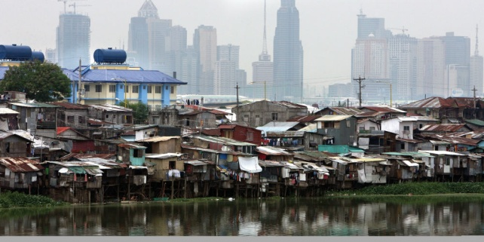](http://newsinfo.inquirer.net/files/2012/08/floodway-banks.jpg)

Bar graph:

[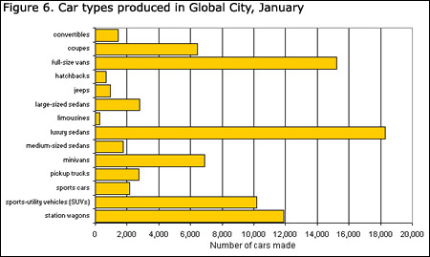](http://www.statcan.gc.ca/edu/power-pouvoir/ch9/img/5214818_06-eng.jpg)

Pie chart:

[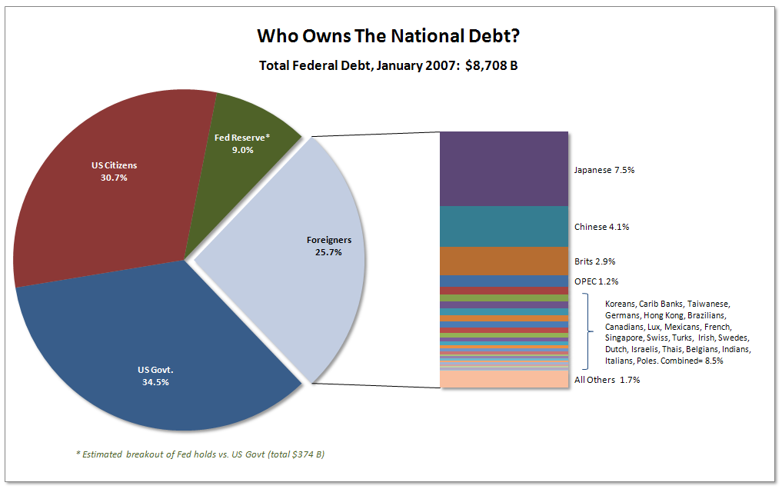](http://j-walkblog.com/images/piechartalternative2.png)

Map

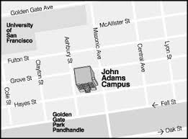

Table

[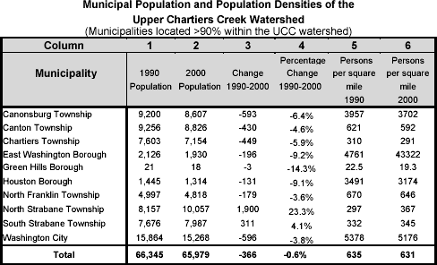](http://www.upperchartierscreek.org/images/population_table.gif)

Process graph

[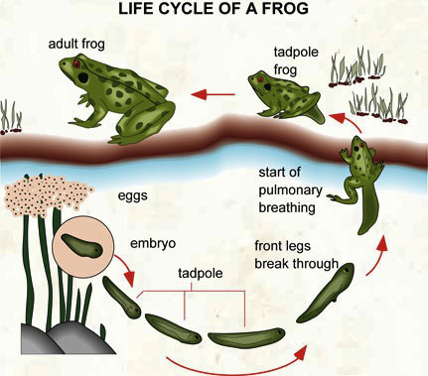](http://i1.wp.com/ieltsliz.com/wp-content/uploads/2014/11/froglifecycle.jpg)

Venn diagram

[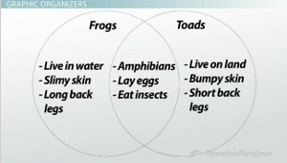](http://study.com/cimages/multimages/16/venn-diagram-example.jpg)

**#2. Get yourself a framework**

You can use below framework when describing an image. Remember you only have 40 seconds to speak, so make use of it and do not speak beyond the timing. Otherwise, the system would mark your answer as incomplete.   
  
What you need to speak about:  
A. Overview  
The chart shows the future trends in the percentage of American citizens over 65 years old.  
  
B. Point 1  
In 2010, about 13 percent of US citizens were over 65. This figure is predicted to rise steadily so that by 2035, it will be 20 percent.  
  
C. Point 2:   
Between 2010 and 2030, the rise will be quite steady whereas between 2030 and 2035, the rise is less significant. – suggesting that the increase in the aging population may peak shortly after 2035.  
  
D. Conclusion/Prediction.  
However, the rise will have serious implications in areas such as the provision of government services.  
  
Often the image will have too many details, do not get yourself overwhelmed by this, you only need to identify two points and you can ignore the rest.   
Keep in mind that the test is not designed for you to speak about all the details, it is not possible in such short period of time.

**#3. Practice, review, repeat**

My last tip would be a simple one, keep your smartphone ready, then record your answer and review. Make sure you have finished your last sentence before it hit the 40-seconds mark, aim for 38-39 seconds.  
  
Good luck!